FILM
MISSISSIPPI BURNING

Mississippi Burning is a film based on the investigation into the real-life murders of three civil-rights workers in Mississippi in 1964. the movie focuses on two fictional FBI agents who investigate the murders.

The movie highlights the injustice of Southern American Society in the 1960’s. Anderson and Ward are given the task of investigating the fate of the three Civil Rights Boys. While they investigate, they uncloak the social inequality in Mississipi.

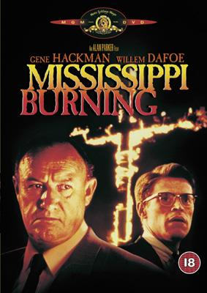 | Questions on the film  Scenes 1 through 4  - What happened to the missing boys? Explain what you saw in the opening sequence.  - The black people and the white people did lots of things separately. Can you name some of them?  - How did the local police react to the FBI agents?  - One of the FBI agents told a story about his father to explain why people are racist. Why did he think that they were racist?  - Are the black people in the film helpful towards the FBI agents? Why do you think this might be?  - Why do you think the FBI agents get their window broken and the black boy gets beaten up?
Scenes 5 through 8  - Are the Mississippi townsfolk worried about the missing boys’ whereabouts?  - One lady says that the black folk in Mississippi have been treated fairly. Do you agree? Explain your answer.  - The local businessman said that he did not like Chinese or Black people because he wanted to keep America pure (white). Is this a fair reason to be a racist? Explain your answer.  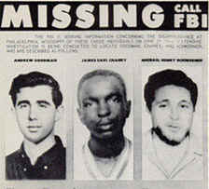 |  | Scenes 9 through 12  - Why would the black boy who was beaten up not press charges? Why would his family not convince him to press charges?  - The black boy who decided to press charges was wearing a box on his head. Why?  - Where did the blacks and the whites sit in court?  - The judge decided that what the white men who had firebombed the black man’s house had done was wrong but that they were under pressure from “outside influences”. Was his decision right? Explain your answer  - How did the black community react to the judge’s decision? How would you have responded if you had been in that situation?  - Why was the black man hung?  - At the political meeting what were their reasons for not wanting to give black people equal rights?
Scenes 13 through 16

- Was the FBI right to get the confession out of the mayor in the way that they did?
- Why could the FBI not charge the killers with murder even when they had Lester’s confession?
- The mayor wasn’t actually involved in the killing but the FBI agent called him guilty for having allowed this to happen. Was he guilty? Explain your answer.
- The maximum jail sentence that any of the killers received was 10 years. Is that long enough for what they did? Why or why not?
- The FBI finally got the killers arrested. Was it worth it for all the extra trouble that they brought with them? Explain your answer.

